1. Funding Method: Venture Capital

Reasoning:

Opting for venture capital (VC) as the funding method for Island Sentinel: CyberGuard offers a compelling approach that aligns with the company's growth potential and industry dynamics. Here's why venture capital could be a more suitable choice:

1. Capital for Scaling: Venture capital firms specialize in providing significant amounts of capital to startups with high-growth potential. Given Island Sentinel: CyberGuard's innovative cybersecurity solutions and promising market opportunities, VC funding can provide the necessary financial resources to scale operations rapidly.

2. Accelerated Growth: Venture capital can enable Island Sentinel: CyberGuard to accelerate its growth trajectory. The substantial funding can be used to hire top-tier talent, invest in cutting-edge technology, expand marketing efforts, and penetrate the market more aggressively.

3. Industry Expertise: Venture capital firms often have teams with deep industry knowledge and experience. Their insights can guide strategic decisions, help navigate challenges specific to the cybersecurity sector, and position the company for success in a competitive market.

4. Strategic Partnerships: Venture capitalists often have extensive networks and connections within the industry. These connections can facilitate strategic partnerships, collaborations, and access to potential clients, thereby boosting the company's market presence and credibility.

5. Operational Support: Venture capital firms typically provide not only funding but also operational expertise and mentorship. This support can help Island Sentinel: CyberGuard refine its business model, streamline operations, and make informed decisions that contribute to long-term success.

6. Scalability and Market Penetration: Venture capital can fuel rapid market penetration and expansion efforts. With the financial backing to explore new markets and establish a strong presence, the company can capitalize on its innovative solutions and capture a larger customer base.

7. Exit Strategy Alignment: Venture capitalists are often interested in a successful exit, such as through acquisition or initial public offering (IPO). Their expertise in navigating such scenarios can help Island Sentinel: CyberGuard position itself strategically for a lucrative exit when the time is right.

8. Access to Resources: Venture capital firms have resources that extend beyond capital, including mentorship, industry insights, and access to other portfolio companies. This ecosystem can provide a rich environment for learning, collaboration, and growth.

Pitch

"Island Sentinel: CyberGuard is poised to revolutionize the cybersecurity landscape. With a dedicated team of seasoned professionals and cutting-edge technology, we offer tailored solutions to safeguard businesses against evolving digital threats. Our proactive approach, commitment to personalized service, and track record set us apart. We seek funding to accelerate growth, expand our client base, and make the digital world safer for businesses across the Caribbean."

Financial Projections:

Year 1:

Revenue: JMD 15,000,000

Expenses:

Salaries for Outsourced Experts: JMD 6,000,000

Software and Tools: JMD 2,500,000

Marketing and Sales: JMD 1,500,000

Office Expenses: JMD 1,000,000

Legal and Professional Fees: JMD 1,000,000

Miscellaneous Expenses: JMD 1,000,000

Net Income (Projected): JMD 2,000,000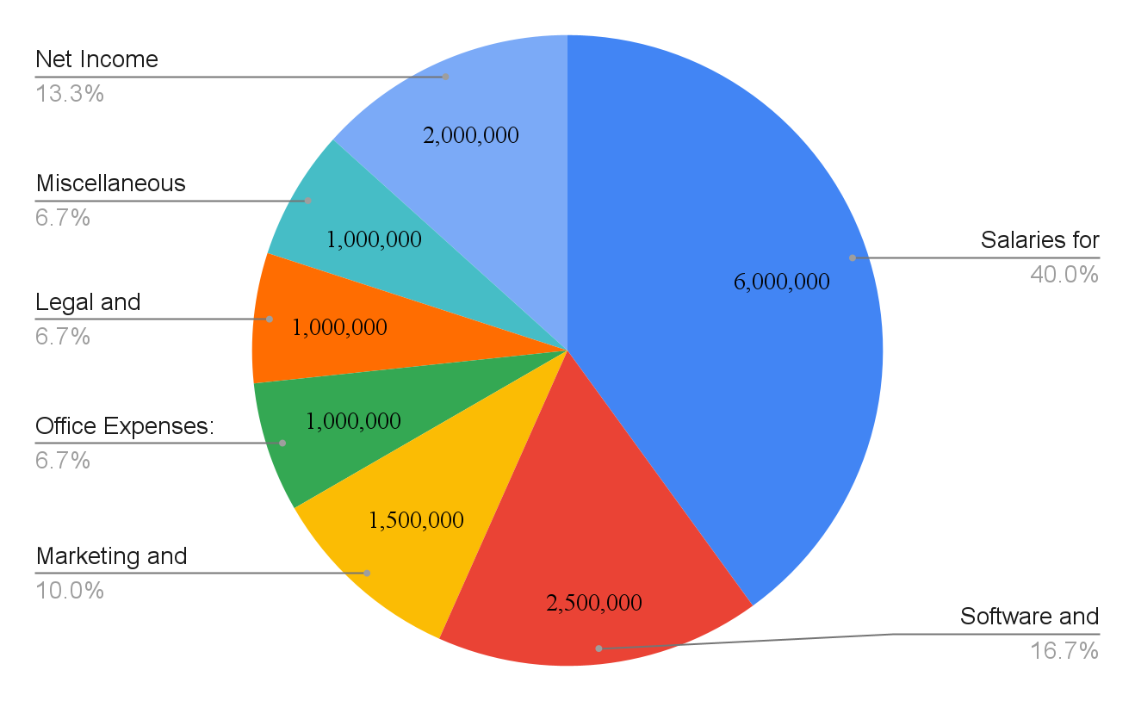

Year 2:

Revenue: JMD 25,000,000

Expenses:

Salaries for Outsourced Experts: JMD 10,000,000

Software and Tools: JMD 3,000,000

Marketing and Sales: JMD 2,000,000

Office Expenses: JMD 1,500,000

Legal and Professional Fees: JMD 1,500,000

Miscellaneous Expenses: JMD 1,500,000

Net Income (Projected): JMD 5,500,000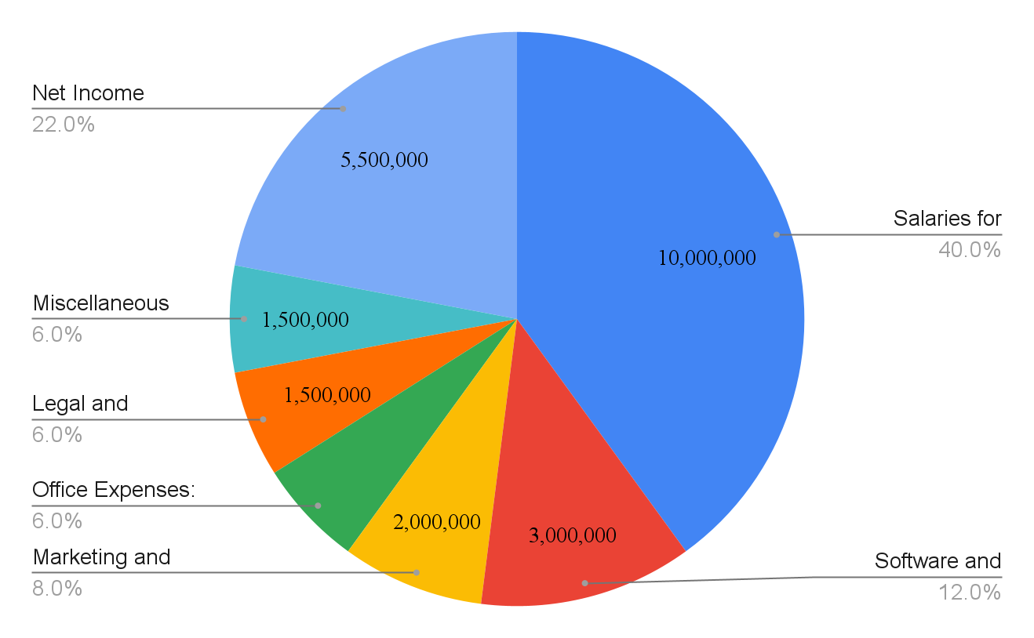

Year 3:

Revenue: JMD 40,000,000

Expenses:

Salaries for Outsourced Experts: JMD 16,000,000

Software and Tools: JMD 4,000,000

Marketing and Sales: JMD 2,500,000

Office Expenses: JMD 2,000,000

Legal and Professional Fees: JMD 2,000,000

Miscellaneous Expenses: JMD 2,000,000

Net Income (Projected): JMD 11,500,000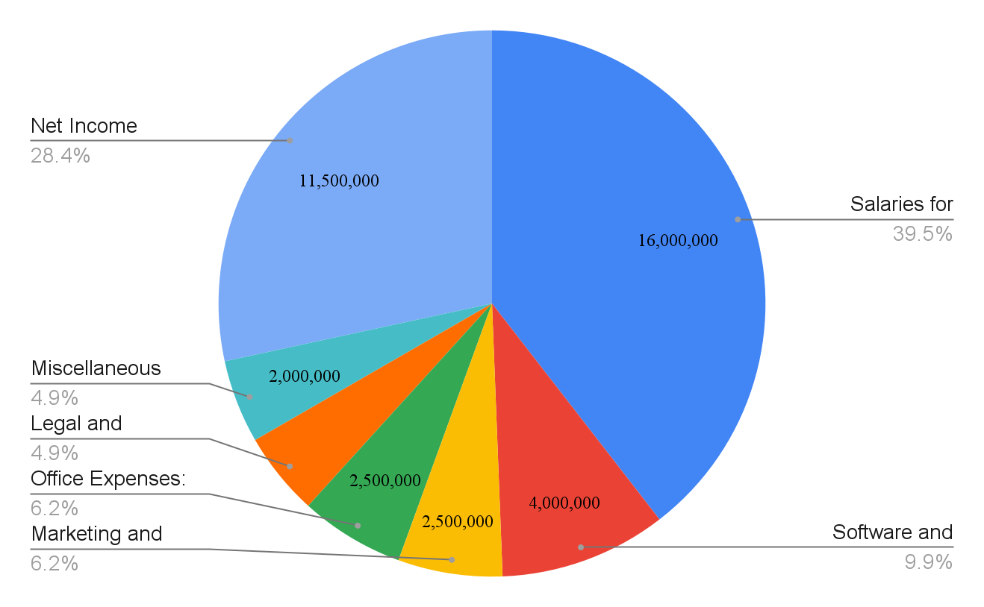

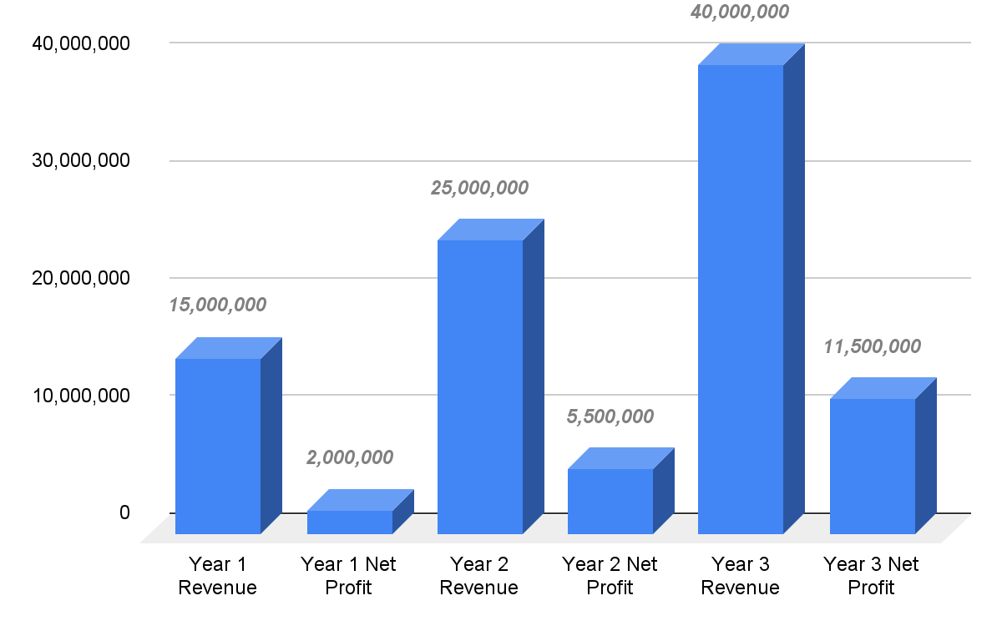

Managing Cashflow

1. Cash Flow Forecast:

Develop a cash flow forecast that outlines your expected cash inflows and outflows on a monthly or quarterly basis. This forecast will help you anticipate periods of surplus and potential shortfalls, allowing you to take proactive measures.

2. Payment Terms:

Negotiate favorable payment terms with clients and suppliers. Request upfront deposits from clients before starting projects to improve cash flow. Extend payment terms with suppliers if possible to align with your incoming funds.

3. Expense Prioritization:

Prioritize essential expenses such as salaries, software subscriptions, and office rent. Delay non-essential purchases or discretionary spending to maintain a healthy cash balance.

4. Emergency Fund:

Set aside an emergency fund to cover unexpected expenses or cash flow gaps. Having a buffer can provide peace of mind during challenging periods.

5. Invoice Management:

Send invoices promptly and follow up on overdue payments. Implement a system for tracking invoices and ensuring timely collections.

6. Credit Management:

Manage credit terms with suppliers to avoid straining cash flow. Negotiate favorable terms that align with your revenue collection cycle.

7. Contingency Planning:

Identify potential risks that could impact your cash flow, such as economic downturns or unexpected expenses. Develop contingency plans to address these risks and maintain financial stability.

8. Monitor Expenses:

Regularly review your expenses to identify areas where you can optimize costs. Look for opportunities to reduce unnecessary expenditures without compromising quality.

9. Budget Review:

Regularly review your budget in comparison to actual performance. Adjust your forecast and strategies as needed based on real-time data.

10. Financing Options:

Consider securing a line of credit or short-term financing as a safety net. Having access to additional funds during tight cash flow periods can provide flexibility.

11. Long-Term Strategy:

Align your cash flow management with your long-term growth strategy. Ensure that your cash flow strategies support your expansion plans and goals.

12. Professional Financial Management:

Consider hiring a financial professional or consulting with an accountant to provide expert advice on cash flow management, budgeting, and financial strategy.